Avinav Nakarmi

Wireframe for final project

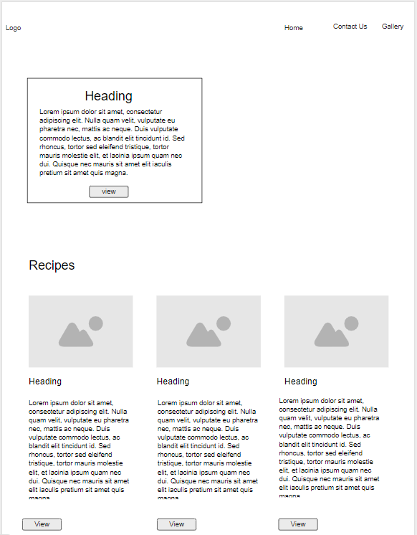

Figure : Landing Page – Section 1

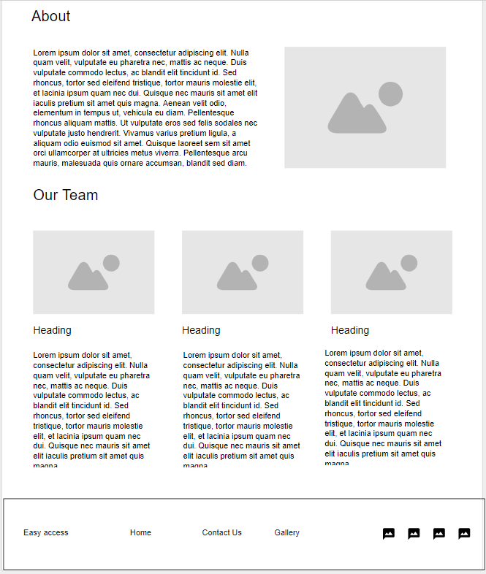

Figure : Landing Page - Section 2

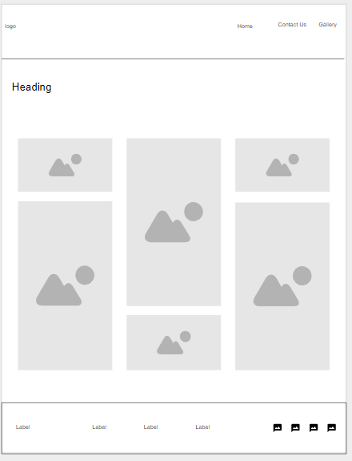

Figure : Gallery Page

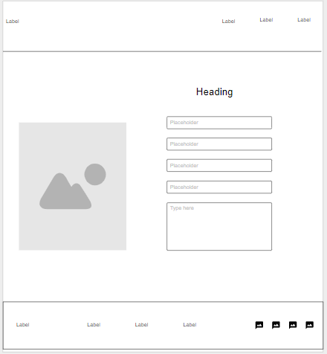

Figure : Contact Form

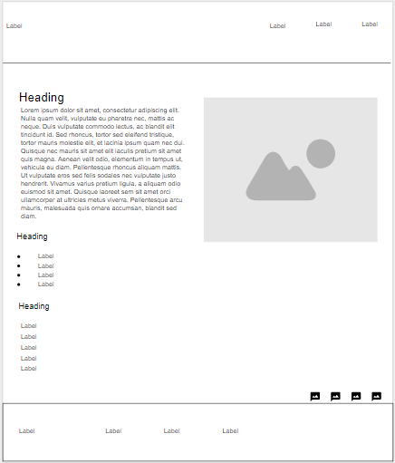

Figure : Recipe Instruction Page